- Helm Chart Architecture?
- Helm Chart CLI ?
- First “Hello World ” Helm Chart

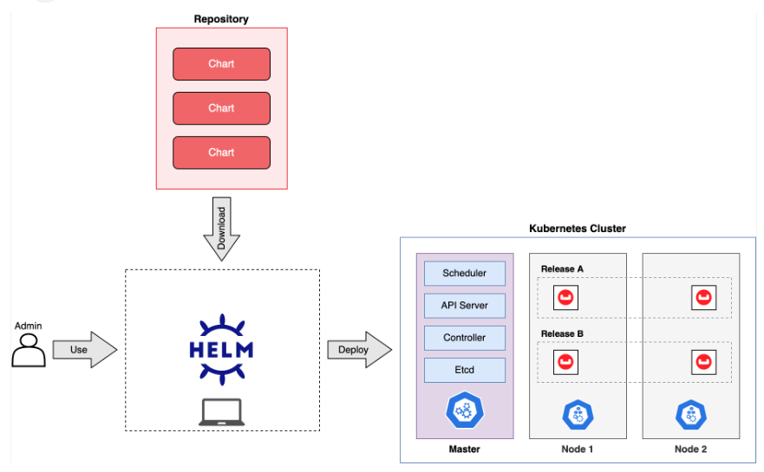

helm create helloworld
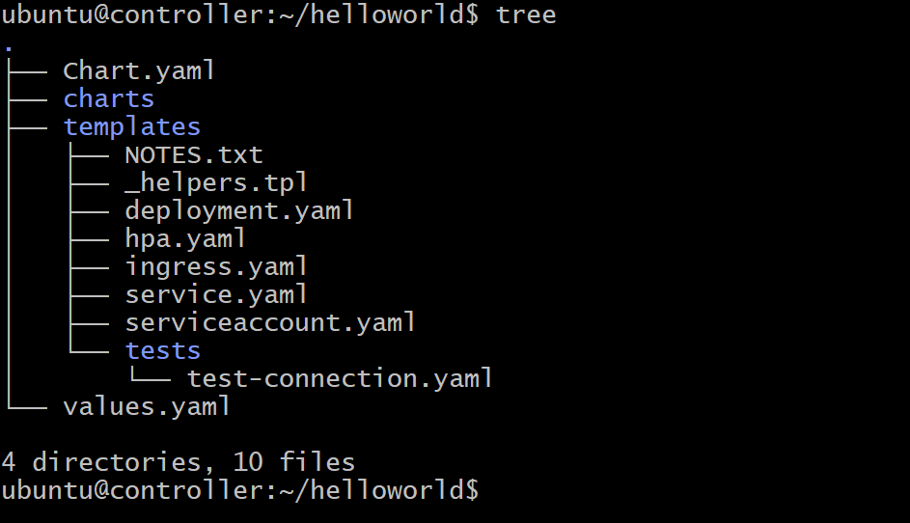

Vi values.yaml
Change service.type = NodePort

helm install myhello_deployment helloworld
Or
microk8s helm3 install myhello-deploy helloworld/

microk8s dashboard-proxy
change http to https
https://3.84.4.150:10443/
Login token
